Elements, compounds and mixtures quiz
- Define an element.

- An element is any substance that we use, such as sugar in a cake.
- An element is a substance that has been broken down.
- An element is a pure substance that we use in a mixture to make things.
- An element is an absolutely pure substances that cannot be broken down into simpler substances.

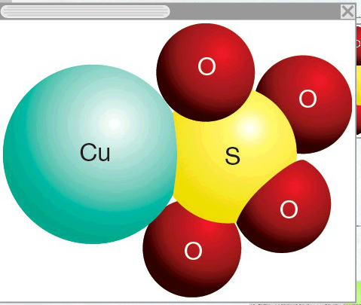
- Identify what this diagram represents

- An impure substance
- A pure lattice
- An element
- A compound

- Identify the correct statement about mixtures.
a. Mixtures contain two or more substances.
b. all of the answers are correct.
c. Substances in mixtures are not chemically bonded together.
d. Mixtures can be separated.

- Identify which of the following is an element.

- Plastic
- Paper
- Sugar
- Carbon

- Identify the correct symbol for sodium

- No
- S
- So
- Na

- Define the term ‘compound’

- A synthetic substance created in the laboratory
- A pure substance made up of more than one type of atom
- A pure substance made up of only one type of atom
- A group of atoms bonded together.

- Recall which term best describes air.

- A mixture
- An element
- A compound
- An alloy

- Quartz has the chemical formula SiO_{2.} Assess what this chemical formula tells you about the mineral quartz.

- For every atom of oxygen, there are 2 atoms of silicon.
- Silicon and oxygen form groups, containing two of each type of atom.
- One atom of silicon bonds with one atom of oxygen, to make a group containing two atoms.
- For every atom of silicon, there are 2 atoms of oxygen.

- Identify the correct statement. An atom of fluorine (F) that has an atomic number of 9 and an atomic mass of 19 contains:

- 9 protons, 19 neutrons and 10 electrons.
- 19 protons and 9 electrons.
- 9 protons, 9 electrons and 10 neutrons
- 10 protons, 9 neutrons and 9 electrons

- Recall the maximum number of electrons that can be in the inner-most electron shell of an atom:

- 16
- 4
- 2
- 8

- Identify the correct chemical symbol for barium

- ba
- Ba
- Any of these symbols can be used
- BA

- Identify the correct definition for the term ‘ductile’.

- A substance that breaks easily.
- A substance that can be rolled into thin sheets.
- A substance that conducts electricity
- A substance that can be drawn into long wires.

- Identify which statement correctly describes the structure of an atom.

- A nucleus made up of electrons surrounded by a cloud of protons and neutrons.
- A nucleus made up of protons and neutrons surrounded by a cloud of electrons.
- A nucleus made up of protons and electrons surrounded by a cloud of neutrons.
- A nucleus made up of electrons and neutrons surrounded by a cloud of protons.

- Recall the charge of a proton.

- -1
- +1
- Unknown
- 0

- Define the term ‘atomic number’.

- The number of protons in the nucleus of an atom.
- The number of protons and neutrons in the nucleus of an atom.
- The number of neutrons in the nucleus of an atom.
- The number of atoms in a molecule.

- A sugar molecules contains 6 carbon atoms, 12 hydrogen atoms and 6 oxygen atoms.
Determine which of the following molecular formulae would describe this compound:

- C₆H₁₂O₆
- 2C₃H₆O₃
- All answers are correct.
- 3C₂H₄O₂

- Identify the best definition of a scientific model.

- An exact replica of something, only smaller.
- An imaginary representation of something that cannot be seen or proven.
- A Scientific theory that cannot be proven by direct observation.
- A simplified representation of something that explains some of its properties.

- Identify which of the following statements is NOT part of Dalton’s Atomic Theory of Matter.

- Atoms can be broken down into smaller parts.
- Elements are substances made up of just one type of atom.
- All matter is made up of atoms.
- Atoms cannot be created or destroyed.

- Identify which of the following is a compound.

- Titanium
- Brass
- Carbon dioxide
- Air

- Identify the property of an atom that determines which element the atom belongs to.

- The number of electrons in the electron cloud
- The number of neutrons in the nucleus
- The number of protons in the nucleus
- The number of protons and neutrons in the nucleus.

- Define the term ‘alloy’
- A mixture of metal with other metals and/or non-metals.
- A mixture of a metal with a non-metal
- A mixture of two non-metallic elements.
- A metallic compound.
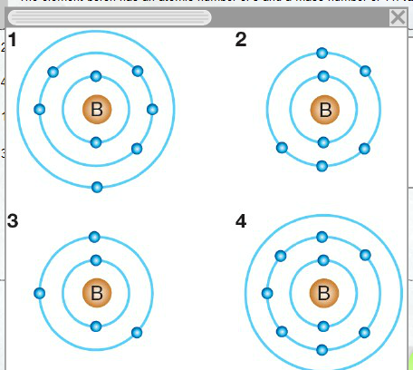
- The element boron has an atomic number of 5 and a mass number of 11. Identify the diagram that correctly shows this atom.

- 4
- 2
- 1
- 3

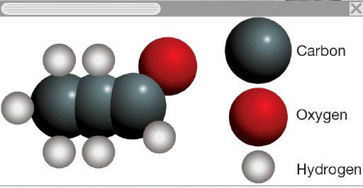
- Determine the correct molecular formula for this molecule.

- C₆H₃O
- C₃H₆O₃
- C₃H₆O
- C₃H₆N

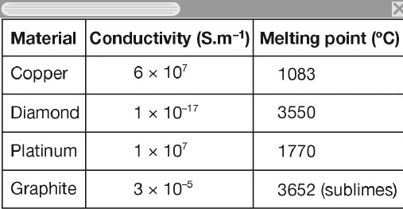
- Use the table to determine which material would be best for electrical wiring in an industrial kiln where temperatures reach 1000°C.

- Graphite
- Copper
- Platinum
- Diamond

- Determine which electron configuration represents a neutral atom.
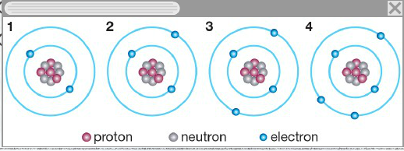
- 2
- 3
- 1
- 4

